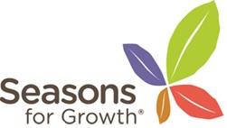
Does the Seasons for Growth* program work?

Since its launch in 1996, Seasons for Growth* has been independently evaluated numerous times. Details of these evaluations can be found on the Good Grief website. The various evaluations have investigated slightly different aspects, age-groups or influences of the program. However, individually and collectively, they highlight that the Seasons for Growth* program has a strong positive effect on children and young people. In addition, they demonstrate that parents, Companions, school principals and agency managers all believe the program is highly beneficial to participants.

The keys aspects particularly valued by young people completing the program are:
- understanding they are ‘not the only one’ - reducing their sense of isolation
- learning to understand and attend to their feelings
- being allowed to express their feelings without being ashamed of them
- the peer support system – learning to trust in others and be trusted
- the opportunity to voice and make sense of their story
- learning that overwhelming feelings associated with grief don’t last forever
- being supported to learn about choices and decisions
- being encouraged to identify and engage with social networks.

As a result participants say they are able to:
- communicate better with their parents and siblings
- understand that life moves forward and that changes do happen
- cope better with their emotions.

