[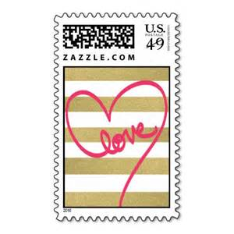](http://www.bing.com/images/search?q=bold+postage+stamp&view=detailv2&&id=0960FA110CB3C4113A61349FDE7A903295EC463E&selectedIndex=12&ccid=IjSc2dl4&simid=608046934921446783&thid=OIP.M22349cd9d9789acf9c79ee93b16ddb82o0)

**FAN MAIL**

**To:**